**CS 371 Final Report**

**Team Sheet**

Joe O’Mara

Haocong Xue

Donal Cavanaugh

**The Concept**

*What is the game about?*

Our proposed game will be about driving a car around and collecting points. The main idea is that you can control a vehicle and you want to avoid obstacles while collecting coins and causing as much destruction as possible.

*Character Design*

The artistic rendition of the enemies came from pre-existing sprite sheets found online (opengameart.org). As for the story, the character is a standard driver with a love of destruction.

*References*

* Extreme City Roof Jump Car Stunts Game 3D 2017
  + The same concept of driving through obstacles

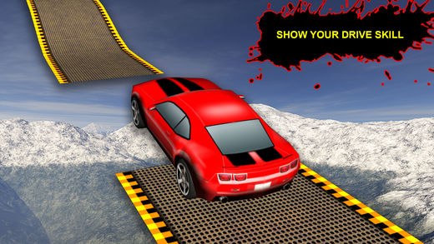

* Carmageddon
  + We took our destructive elements from this game.

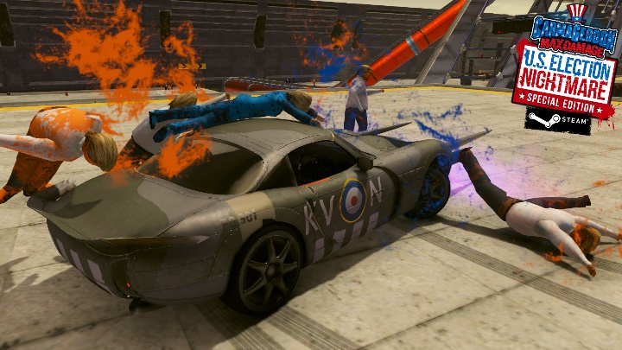

*Genre*: Action

*Target Audience*

Children seem to love destruction, so the target audience for this game will be children ranging from age 12 to age 20. As destruction seems to be a male trait, the game will mainly target males.

**Game Mechanics**

*Gameplay*

Players control, avoiding enemies and obstacles, all the while trying to catch all of the powerups or cause destruction so that they can increase their score.

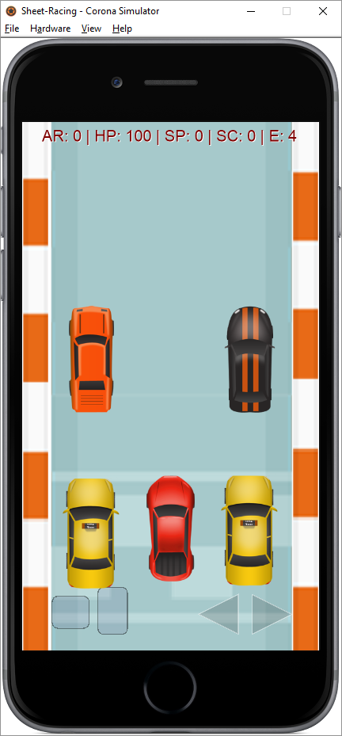

An example of this can be found in the picture above. The car is controlled by the player (the red car) and the enemies are the other cars. Below you can see an example of destructibles that can be hit for a higher score (in this case, a person):

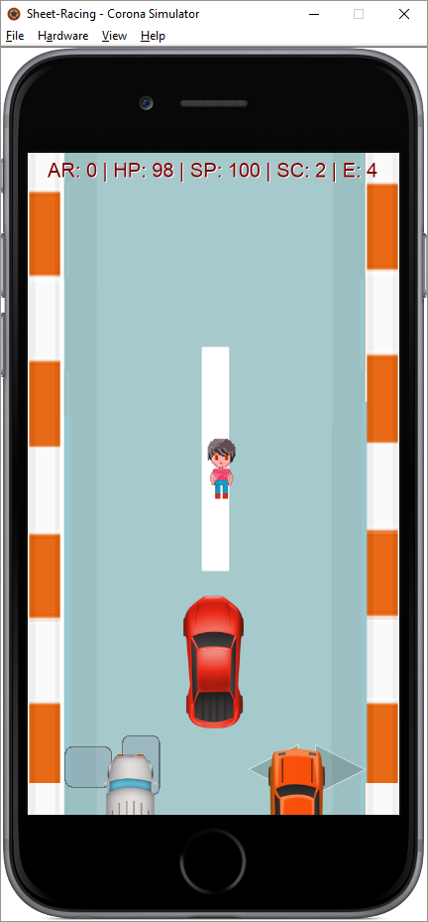

A typical game lasts 90 seconds and a player will race against (or try to destroy) the enemy vehicles and run over people and squirrels to increase their score. If the player is able to destroy all enemy cars, then they win. Otherwise, if you survive the 90 seconds, then you will have your score added to your currency.

*Graphical User Interface*

There are three basic elements to the gameplay screen: gameplay, controls, and alerts. The gameplay element is just that, gameplay; where all of the action takes place. The controls element is how the player interacts with the game. There is a gas pedal, a brake, and controls for moving left and right. Finally, the alerts element displays how much armor, health, speed, score you have, as well as how many enemies are left standing.

*Player Statistics*

* Health – This is an indication of how much more damage you can sustain before your vehicle explodes (try to keep this above zero if you want to win).
* Armor – Armor has the ability to absorb damage that you would have otherwise taken to your health (the more armor, the higher that chance this occurs).
* Speed – This is simply how fast your vehicle is currently going, but be careful because hitting anything causes this to go down.
* Score – This is just how high of a score you currently have (destroy more things to increase this!).

*Scoring*

If you survive a round, your currency is increased by the score that you achieved. You can use this currency to purchase unlockables showed below:

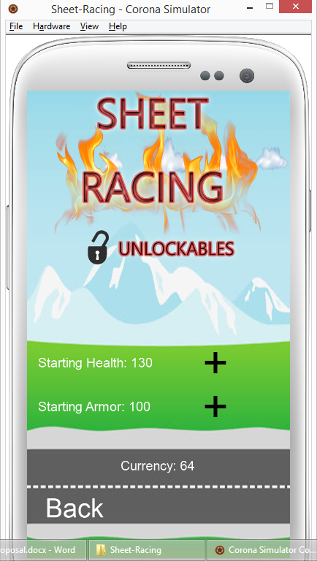

* Collecting Drops
  + The idea is that, in addition to environmental hazards that can hurt your car, there are things that help it out (i.e., repair pickups, etc.).
* Destroying Things
  + The goal of the game is to cause mayhem, so destroying objects like people and squirrels increase your score as well. You can imagine that this game is like a shooter, but with cars.

*Extendibility*

* Modifications to your vehicle
  + Powerups
    - Starting Health – How much health your vehicle begins with.
    - Starting Armor - How much armor your vehicle begins with.

*Screen Flow*



End Screen

|  |  |
| --- | --- |
| Screen | Functions |
| Title | Credits, Go to upgrades, Go to settings, Start new game |
| End Screen | Go to the end of the game |
| Vehicle Upgrades | Purchase upgrades, View currently equipped upgrades |
| Game | Pause, Resume, Quit |

**Tech**

*Required Resources*

* Corona SDK
  + Physics engine
    - Handles car collisions
    - Allows vehicles to move around our map
  + Audio engine
    - Handles delivering sound effects to the user
    - Handles delivering the background music
* Git
  + Used for source control
* Dropbox
  + Used to share live documents with one another that detail schedules and work assignments

*Asset List*

|  |  |
| --- | --- |
| Asset Name | Description |
| map.png | A sprite sheet used as the background image. |
| titlebg.png | A background image for the title screen. |
| Car.png | A sprite sheet used to give all vehicles their image. |
| blood.png | A sprite sheet used to animate a dying person or animal. |
| explosion.png | A sprite sheet used to animate a car exploding. |
| hp.png | An image used for the health powerup. |
| heart.png | An image used for the health powerup. |
| AM.png | An image used for the armor powerup. |
| armor.png | An image used for the armor powerup. |
| npc1.png | A sprite sheet used to spawn people. |
| npc2.png | A sprite sheet used to spawn other people. |
| squirrel.png | A sprite sheet used to spawn squirrels. |
| unlockables.png | An image used for the background of the unlockables scene. |
| gameover.png | An image used for the background of the ending scene. |
| explosion.wav | A sound that occurs when a car explodes. |
| hp.wav | A sound that occurs when a player picks up a health boost. |
| hurt.wav | A sound that occurs when running over a person. |
| whack.wav | A sound that occurs when the player hits another car. |

*Target Platform*

Android

*Screen Resolution*

600x325

**Discussion**

*Missing Components*

Originally, we wanted to add a way to jump over missing parts in the map, but we ran out of time to implement this. We found that a racing game was much more difficult to do in Corona than we were expecting, so much of our time became dedicated to figuring out how to implement racing, and then how to take care of catchup mechanics to make the game more fun and exciting to play. The technology to jump would require new assets for the animation and time spent figuring out how to implement a randomly-generated break in the map.

**Team Collaboration**

**Testing**: All

**Implementation**: All

**Documentation**: Joe O’Mara

**OOP Design**: Joe O’Mara & Donal Cavanaugh

**Project Idea**: Haocong Xue & Donal Cavanaugh

**GUI**: Haocong Xue & Donal Cavanaugh